IE 421

Doggle, The Social Media for Dog Owners

Nathan Allen, Jake Isaacs, Jake Prophet, Eduardo Tomazeli

6 May 2019

**Abstract/Summary:**

In the United States, 65% of the population own dogs. Dogs are an extremely important part of millions of people’s lives, which is why it is important that these people have easy access to information about dogs so that they can take the best care of their dogs. This is the mission behind Doggle. Moreover, we provide a social platform all about dogs, so that dog lovers can socialize, learn from each other, organize events, meetup with their dogs, and much more! We have created a service that will reach out to dog owners in order to interconnect the local and global dog communities through discussion boards, messaging services, and live feeds. This service will allow users to interact and create personal connections with fellow dog owners.

**Introduction:**

For this project, our group plans on creating a website that allows dog owners to interact with other dog lover’s and new dog owners. We will create a social media entirely dedicated to dog events, articles, and social gatherings. This website will allow users to interact with one and other on everything from proper doggy diets to planning local doggy play dates. We plan on including extra features such as dog park locations as well as active owner locators for users to meet up with their dogs favorite friends at their favorite locations. As a group we have settled on Javascript, HTML 5, and MySQL as the preferred programming languages.

**Business Rules:**

Since this application will be devised for personal usage, we have decided to incorporate multiple features that assist in creating the best experience for each user. Those who wish to use this application will be able to create their own personal profile that incorporates their dog’s information such as breed, age, weight, and gender. This information will be used so other users can interact with users with similar dogs and even learn about other breeds. The profile will be accessible through a personal username or email and password for personal privacy. Privacy and human interaction will be paramount given this app will allow for discussion boards for communication between users. This will allow for a much more personal way for users to understand what exactly their dogs can eat, how it reacts to certain changes and even training methods. Due to the fact that there might be a difference between breeds, ages, and weight it is important to us that our application doesn’t make animals ill. We plan on using this discussion section to allow user input to deal with these more specific cases but also be clear on the fact that a certified veterinarian should always be consulted before doing anything to your dog.

**What Data Will be Captured:**

The majority of data that will be captured will be user generated. In order to sign up with Doggle one will simply need to supply a username, email, date of birth, and password of which will be securely saved for times when you may forget your password. Photos will be captured in order to save them to the servers for future user use. As a company we will never sell information for profit however we will collect proper data in order to optimize user

**Frontend Design:**

The frontend of this site was designed using Visual Studio Code taking advantage of the live server feature to understand the changes we were making. The frontend was mainly designed by taking templates found on various websites while making necessary changes to make the site our own. This process forced us to learn the functions of HTML in order to create a fluid user interface. Finally, we utilized w3schools to further understand the functions of HTML so that we could make changes to templates in order to create beautifully simple pages.

**Backend:**

The backend currently is fully operable in allowing a user to create an account, login to an account, and modify an account password. It stores or modifies from the user table of the sql database. While not stored in the backend, we did allow the messenger to type live-update messages. With a bit more time we would’ve liked to have better implemented the backend aspects of storing posts, comments, and messages. However, we were still successful in creating the feel of signing-up and/or logging into a social media account for dogs.

**Core Functions:**

There are several core functions that are provided by Doggle. The first is the basic social media function which allows users to create posts and upload pictures, make comments and like posts, as well as add friends. The second core function is the ability for users to direct message one another in order to interact on a personal level. Lastly, core function is the ability to organize events and meetups.

**End Users:**

The end user to this social media are dog owners and dog enthusiasts. Although “dog people” are the target customers, there are no requirements for being a Doggle User. This will allow for an increased customer pool. Because the user doesn’t necessarily have to own a dog to join our site, this site will allow for other users to get engaged with friends and family members that do in order to have dog related experiences.

**SQL Tables:**

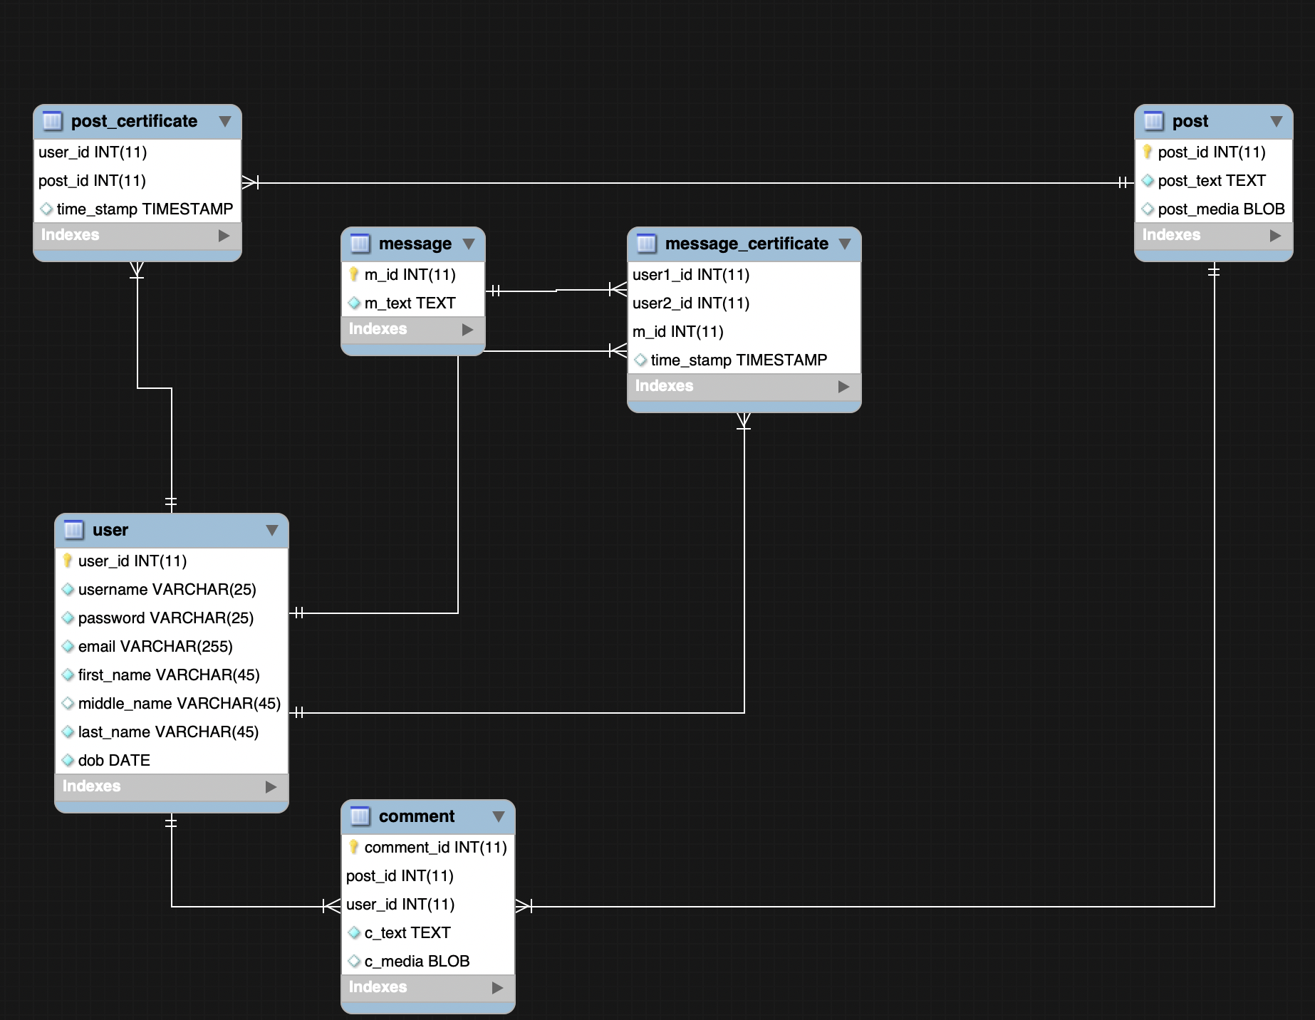

**User Manual:**

**Sign Up:**

* Doggo will begin with a “Sign Up” page. After the user has provided us with the necessary information they will have the ability to customize their profile. In order to create a profile, users will be required to provide us with a username, email, name, date of birth, and password.

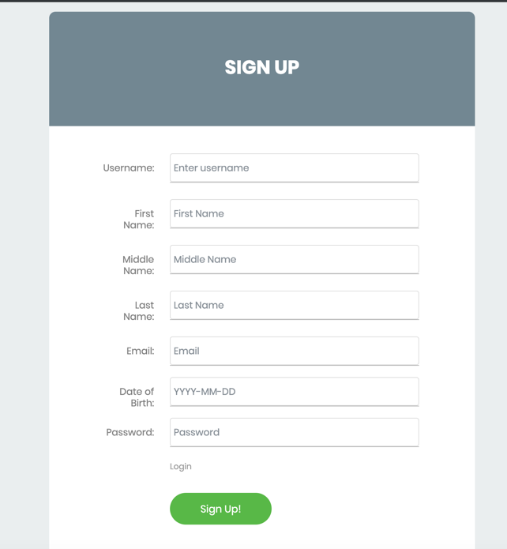

**Friends:**

* Now the user is able to interact with other user’s and become “friends with them”. Users are able to exchange messages, see each other’s posts and comment on them. This can be found under the magnifying icon on the toolbar of the site.

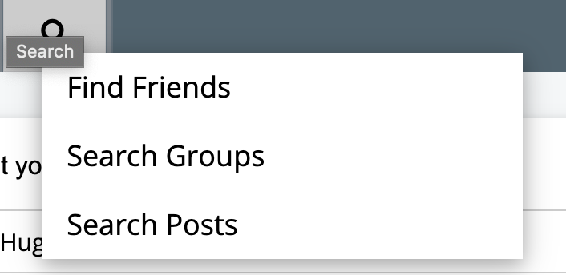

**Events:**

* Not only is the user able to interact with other users, but also with communities with similar interests. The user is able to create events, invite friends to events and join existing events created by other users. This can be found below your user profile on the home page.

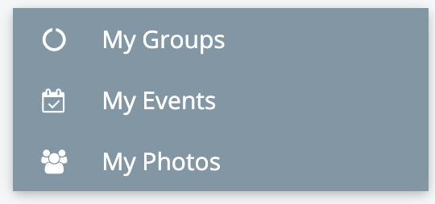

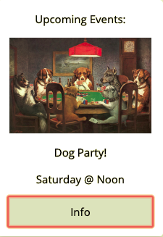

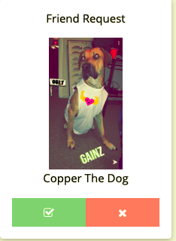

**Notifications:**

* Doggle will also incorporate a notification center that will update users on new events, friend requests, and recent posts. This function will be accessible through the toolbar under the bell icon.

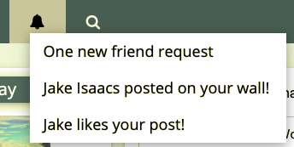

**Account Settings:**

* Users will also be able to change a multitude of settings. This function will be accessible on the toolbar under the person icon. This will also be where events and other features can be accessed.

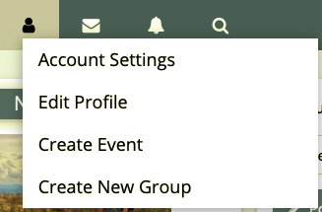

**Messenger:**

* Messaging is a key feature to Doggle. Because of this, we have created a messaging system that allows users to personally interact with each other. This feature is accessible through the toolbar as well.

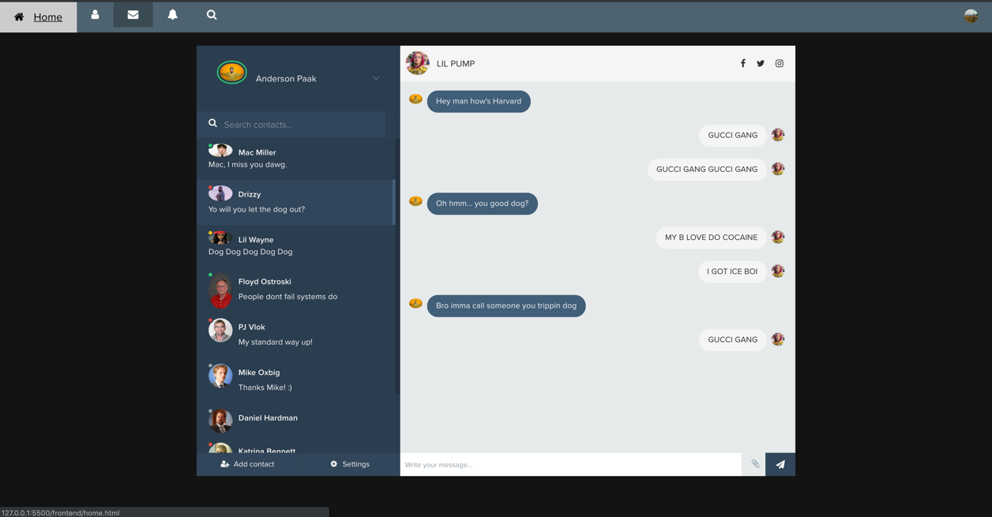

**Forgot Password:**

* There is a forgot password page that allows users to retrieve their password if they have forgotten. This feature will require an email, date of birth, and new password.

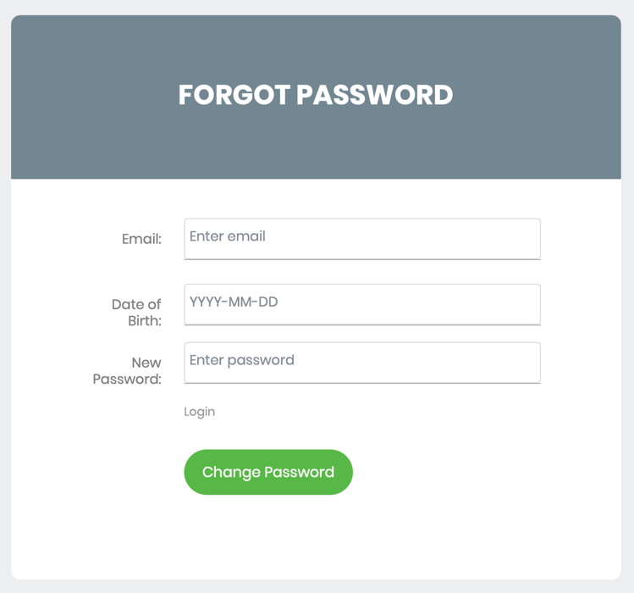

**LOGIN:**

* Finally, the login page is the first page that a user will see. This page requires a username and password. If the user is successful, this page will send users immediately to their home page. If the user is unsuccessful in signing in, the site will notify the user with a failed login message.

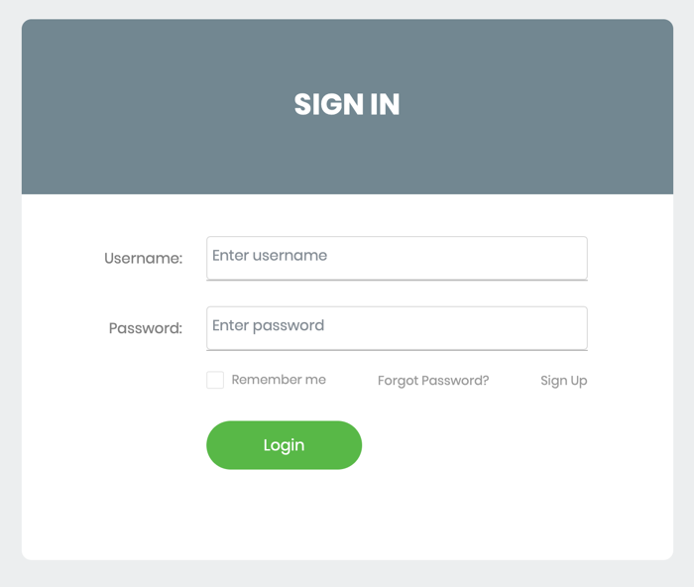

**References**

*User Profile Info (For login, or modifying with site)*

Username: user

Email: user@mail.com1

Password: password

DOB: 1999-08-15

***Running the servers****:*

-Frontend: VS Code LiveServer

-Backend: php -S 127.0.0.1:8080 index.php